Gasless UniSwap Tutorial

This tutorial instructs the steps to install and run the dApp [gasless-uniswap](https://github.com/Morpheuslabs-io/gasless-uniswap.git) which enables decentralized swapping of ERC20 tokens without the need of holding ETH to pay for transaction fee.

Currently-supported network is **Ropsten** Ethereum Testnet

===================

Morpheus Labs forked this source code from <https://github.com/yashnaman/gasless-uniswap> as a reference source for gasless UniSwap demo. Users can explore, modify and test the protocol on Morpheus Labs SEED platform.

Since this is ISC License, for SEED platform users or any users who need to fork or clone this source code need to explicitly fork from this repo.

===================

## **Smart contract**

In the folder **gasless-uniswap**

### 1. Installation

Run this cmd

**npm install**

### 2. Compile, deploy and initialize contracts on Ropsten testnet of Ethereum

- Create a file **.secret** containing the private key of some Ropsten account

- Run this cmd: **truffle migrate --network ropsten**

- Set the deployed contract addresses (printed from the above step) in the file **src/js/config.js** under the section **config.ropsten**

- On the Metamask, these contract addresses should also be added by using the **Add Token/Custom Token**. This is to visualize the tokens and their balances on Metamask wallet.

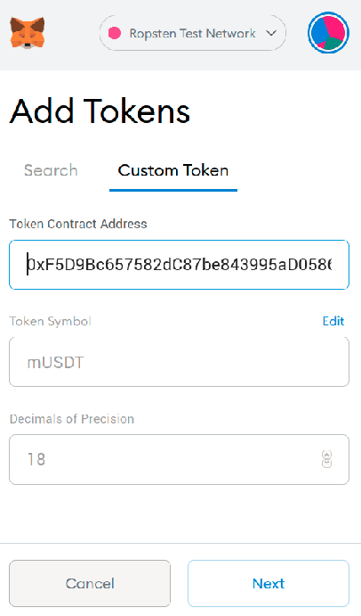

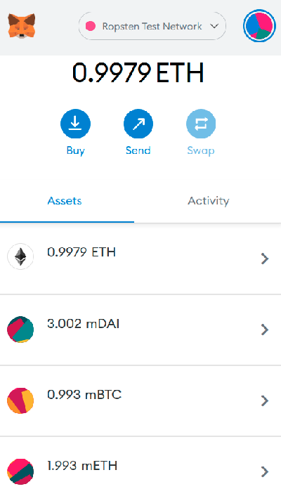

**Notice**

The process **truffle migrate** takes a long time (about 30 minutes) for contract initialization. So, please be patient.

## **Frontend UI**

Go to **src** directory

### 1. Installation

Run this cmd

**npm install**

### 2. Start the frontend

Run this cmd

**npm run dev**

### 3. Open web browser

http://0.0.0.0:9090/

## **How to test swap**

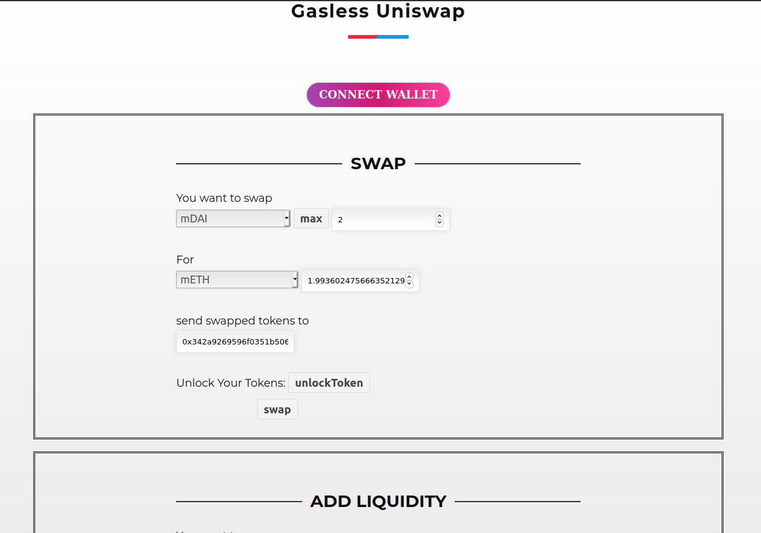

1. Open web browser: http://0.0.0.0:9090/

2. Ensure Metamask connected to **Ropsten**

3. Click **“connect wallet”** to get connected to Metamask

4. For the **“You want to swap”** part, ensure that the currently-connected Metamask account has some tokens of the selected token to be swapped. Can use the account (whose private key is specified in the file **.secret**) that has run the **truffle migrate** cmd to send some tokens to

5. For the **“For”** part, can select any target token to be swapped with

6. For the **“send swapped tokens to”** part, enter some address to receive the tokens

7. For the **“Unlock Your Tokens”** part, ensure to click **“unlock token”** to permit the source token (at the You want to swap part) to be sent out for swap.

8. Click **“swap”** button and check if the entered address receives the tokens or not on Metamask wallet

### **SWAP test transaction result on Ropsten**

**unlock token or permit transaction**

<https://ropsten.etherscan.io/tx/0x9282b118c0da7135beb4454afcb1b38d84cf796cb48092b0bb9fd9ce26150481>

**swap transaction**

<https://ropsten.etherscan.io/tx/0x3297b1e7d05c52d5bab0fb7f32e0eb01690ba8373593049436ffe4a1a39f0a24>

## **How to test Add Liquidity**

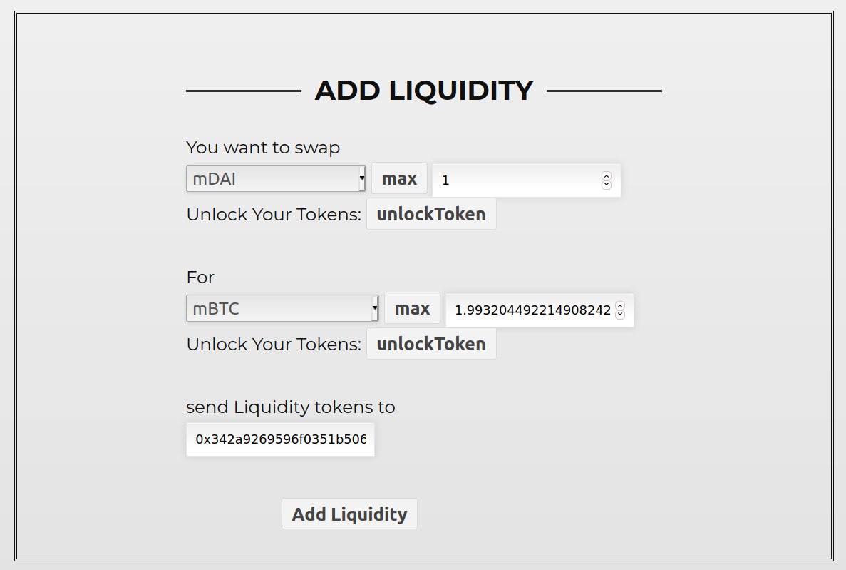

1. Open web browser: http://0.0.0.0:9090/

2. Ensure Metamask connected to **Ropsten**

3. Click **“connect wallet”** to get connected to Metamask

4. For the **“You want to swap”** part, ensure that the currently-connected Metamask account has some tokens of the selected token to be unlocked. Can use the account (whose private key is specified in the file **.secret**) that has run the **truffle migrate** cmd to send some tokens to. Then, click the button **“unlock token”**.

5. For the **“For”** part, do similarly to the step above

6. For the **“send Liquidity tokens to”** part, enter some address to receive the **UNI-V2** tokens

7. Click **“Add Liquidity”** button and check if the entered address receives the **UNI-V2** tokens or not on Metamask wallet

### **ADD LIQUIDITY test transaction result on Ropsten**

**unlock token or permit transaction for the part You want to swap**

<https://ropsten.etherscan.io/tx/0xb627558cebd2500b42b79686d266217759b7ac9aec24dc21bf4c3f9cac1e4f1d>

**unlock token or permit transaction for the part For**

<https://ropsten.etherscan.io/tx/0xe69447609a00a79af844a6f29648b2b241ba8995a68a1134a56839428ed5e085>

**Add Liquidity transaction**

<https://ropsten.etherscan.io/tx/0x2874056a411d302977c521530df59fa8b247e206c3424dae33fe7f952578e6e2>